Project Communication Guidelines (Starter Kit)

Things you should know, things you should do and how we can help you succeed!

Table of Contents
WHY COMMUNICATE? 1
WHO? - PROJECT COMMUNICATION OFFICER 4
WHAT? – YOUR STORY 5
HOW? – COMMUNICATION CHANNELS/TOOLS 8
LOGOS 8
WEBSITES 8
SOCIAL MEDIA 8
VIDEOS 17
PROJECT POSTERS 17
PROJECT BILLBOARDS/PLAQUES 17
PUBLICATIONS 18
NEWSLETTERS 18
PROMOTIONAL MATERIALS 18
EVENTS 19
VISUAL IDENTITY MANUAL 20

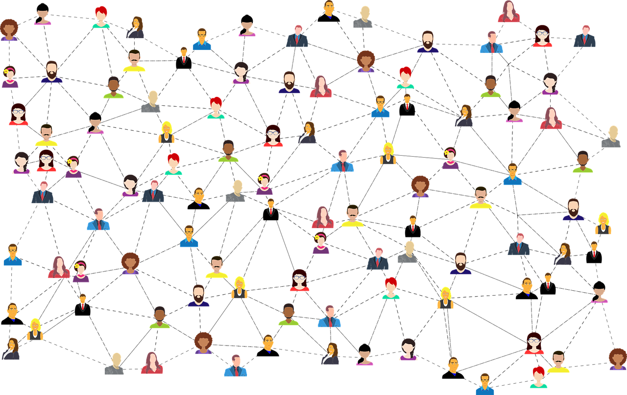

WHY COMMUNICATE?

WHO? - PROJECT COMMUNICATION OFFICERWHY COMMUNICATE?

When it comes to project management, even the best tools won’t matter much without effective communication. In order to achieve the best results, project partners should take building up their communication strategy as seriously as their project strategy. Effective project communication is a key element of successful projects.
Also, communicating the use of European funds in your project is mandatory for everyone who wishes to receive them. Each partner, coordinated by the Lead, is responsible for meeting the European communication requirements for their project.
Communication activities have to be described at the project application stage. Once the project is approved, the lead beneficiaries are encouraged to set up their own communication plans and delivering their own information activities.
Communicating projects is a shared responsibility between the Programme bodies and the project partners. This is why we decided to support partners in their communication activities by creating this Project Communication Guidelines, which will set the grounds for your future communication activities.
We know that there is no “one size fits all” formula for project communication, but it is possible to draw up some general principles for projects funded by the Programme based on our previous experience and good practices.
This document will serve as a guide for meeting the requirements set by the European Union, but we also try to show you what we love about communication, the fun we have while promoting the EU funds, and why it’s one of the most important parts for us, at Programme level, so maybe you can make it one of the most important parts at project level as well. We believe that each project should be implemented with a bit of passion and creativity in order to achieve success, and passion is the best tool for communicating efficiently. Don’t be afraid, try new things, be creative, show us how you’ve changed the world with your project!

WHO? - PROJECT COMMUNICATION OFFICER

WHO? - PROJECT COMMUNICATION OFFICER

We know that project partners are usually focused on the project’s main activities, financial management and contractual obligations and this is normal, but communication activities are just as important as any other activity and having a dedicated and qualified communication officer will positively impact the quality and consistency in the project’s communication. Moreover, communication is not separated in any means of the technical aspects of the project implementation, these are interlinked. | 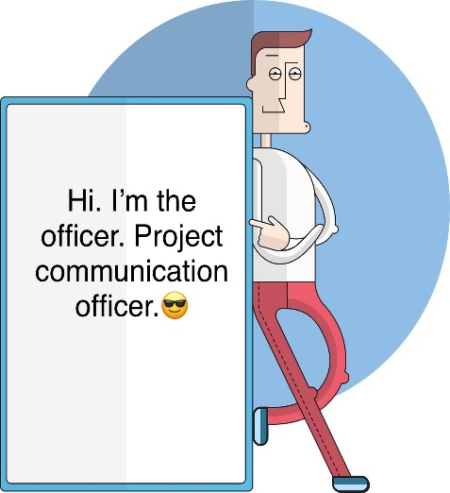
Hence, all project teams will appoint a member to be in charge of communication and information activities. Our advice is that all members of the team unite their forces and collaborate in organizing communication activities whenever it is possible.
The communication officer should be in close contact with all team members, to know when progress is achieved (and can be promoted), to understand when meetings are planned, which can be shared with the public and will keep a permanent contact with the communication officers from JS

WHAT? – Your storyHence, all project teams will appoint a member to be in charge of communication and information activities. Our advice is that all members of the team unite their forces and collaborate in organizing communication activities whenever it is possible.
The communication officer should be in close contact with all team members, to know when progress is achieved (and can be promoted), to understand when meetings are planneH, which can be shared with the public and will keep a permanent contact with the communication officers from JS

Just like in the Interreg VI-A Romania-Bulgaria Programme team, project communication officers need to be supported by their colleagues who are well informed about the projects’ progress with content information, provided in a timely manner.
Project communication officer’s tasks may include:
- Ensure high quality communication at project level.
- Improve visibility of projects and their results.
- Prepare a communication plan or strategy comprising communication objectives, target groups, key messages, activities, channels, delivery timeline, task division among the partners, budget etc.
- Coordinate the implementation of the plan/strategy ensuring consistency of the communication activities across the partnership.
- Collect content.
- Assist with planning, logistics and attend project events.
- Monitor the results of the communication activities and adapt as needed in order to achieve the objectives set.
- Ensure that the rules of the Programme on visibility are observed.
- Contact the JS regarding all communication matters if you need help.
- Inform JS about all communication events organized within the project
- Investigate and exploit project promotion channels.
- Ensuring presence of the project in social media.
- Exchange good practices with other programmes and Interreg projects.

WHAT? – Your story

WHAT? – Your story

Tell us your story!

It all starts with the Application Form. Lead beneficiaries have to provide attractive and interesting project descriptions when writing the application. The aim must be not just to communicate results and the benefits for participating regions but also to allow other projects to develop on them, and investigate and illustrate longer-term benefits for the border area.
Please write it in short sentences and plain language. Sometimes we read long, complicated sentences, which are hard to understand. You need evaluators to understand what you propose (and while they are experts in European funds, they are not necessarily experts in CBRN equipment, for example). Keep it simple, especially since, in case the project is selected for financing, we will use your description to display your project on the Programme website, so that more people will see what amazing things you are doing.

Make a game plan  Planning is everything, so we can’t stress enough the importance of drafting a communication plan.  You are not required to submit it for approval, but we highly recommend you to do it for your own project management and are happy to provide you with feedback upon request.  In plain English, making a communication plan means figuring out:  - Who are you trying to reach?  - What message do you want them to receive?  - How will you try to reach them? | 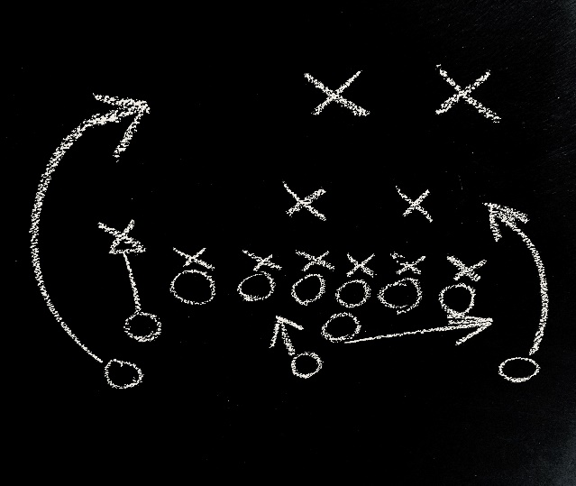
These are simple questions with often complex answers that a documented plan can help clarify.
There is no universal communication plan template available, but a communication plan doesn’t need to be complicated. Developing one will take some effort – and it’s worth it. A communication plan is an essential tool for a successful project and you’ll see it will pay off in the end.

Here are some steps we recommend you to take when drafting your communication plan:

- Define your overall communications objectives. What are the results you want to achieve? What do you want to accomplish by implementing this communication plan?
- You need to know to whom you are delivering your messages. List all the key audiences.
- Depending on the type of the work package, you should set your communication objectives and activities to support your project objectives in achieving a change in the perspective of your target groups, reflecting what new things you want them to learn about your subject, what changes in opinions you want to stimulate, what new things you would like them to do and what things they should stop doing. And last, but not least, try to make communication activities as fun as possible! There should be nothing boring about communicating the amazing things you are building through your projects.
- Deliver your messages through multiple media channels. Decide which media channels would be the most effective to get your message seen/heard. Use social media as it is the most used communication tool nowadays!
- Timing is very important, so schedule your steps in a time framework for the best results
- Don’t forget that communication is a shared responsibility involving all project partners. All the project team shall be committed to the promotion of the project and the dissemination of its good results in their respective countries.
- Master your money. You will have a budget and plan for activities already in place in your application. Include in the project budget the communication activities, human resources and the production of the necessary communication material. Set budget values as rough estimations to enable you to define tools, assign overall resources, but be flexible at the same time.
- It’s always important to evaluate the success of your communication activities in comparison with the communication objectives set in the beginning to see what has worked well and where you need to improve and develop in your future actions. You may evaluate, for example, if you reached out the right target group or if your message was perceived correctly. If you aren’t satisfied with the results, make some changes and try to perform better next time.
When drafting your communication plan, please take into consideration the following minimum package of mandatory communication activities:
Communication activities
1. Organizing a joint opening conference and a closure event (joint final conference of the project)
2. Creating a Facebook/Twitter page
3. Press articles – minimum 2
3. Before and After Photos - minimum 5
4. 1 Short video (1/3 minutes)
5. Promotion of key moments in the life of your project on social media - minimum 2
6. Social media campaign for the promotion of project results

*PS: We will tell you in the following chapters how to promote on social media.

Communication activities
1. Organizing a joint opening conference and a closure event (joint final conference of the project)
2. Creating a Facebook/Twitter page
3. Press articles – minimum 2
3. Before and After Photos - minimum 5
4. 1 Short video (1/3 minutes)
5. Promotion of key moments in the life of your project on social media - minimum 2
6. Social media campaign for the promotion of project results

*PS: We will tell you in the following chapters how to promote on social media.

Specific rules applicable for operations of strategic importance and operations whose total cost exceed EUR 5 000 000
Please have in mind the fact that for operations of strategic importance and operations whose total cost exceed EUR 5 000 000, a communication event involving the European Commission and the Managing Authority must be organized.
Also please note that, according to EU Regulations, the responsibility to involve European Commission and the Managing Authority remains with the project partner.
When you plan your communication event, think of an event with an increased engagement and significant impact for the stakeholders involved and also for the end users, general public/ citizens etc. The event should not address only the people involved/interested in the project but also broader audiences that do not know much about EU funded projects.
Please analyze and select the best communication tools to ensure increased visibility and publicity. Use messages with simple, accessible words. To ensure a strong media impact you may organize a press conference and invite journalists and stakeholders to visit the location of the project, to participate to project events like open doors, fairs etc.
The event may take the form of:
- A dedicated campaign designed in accordance with the objectives of the operation of strategic importance
- An event for opening or closing an activity foreseen for the operation (for ex. opening of a center/investment, finalization of some important works, acquisition of strategic equipment etc.)
- A social media campaign with strong media coverage, involving all significant stakeholders.
For example, you may organize an exhibition, a fair, a conference or a cooperation/entertainment event with the support or in cooperation with the Managing Authority and European Commission, accompanied by a social media campaign to increase its visibility. It is very important to use social media to communicate in the planning stage of the event as well as during the event and after the event. Please take into consideration using different communication platforms (FB, Twitter, YouTube etc.), photos, videos and other visuals.
Involving the Managing Authority, the European Commission and other significant stakeholders, as well as journalists, may increase the media interest that will lead to a higher visibility.
- The Managing Authority and the Joint Secretariat (JS) may offer support to project partners in planning and organization of the event, at the request of the beneficiary, consisting in:
- Setting up a kick-off meeting between JS and the project partners before the implementation of the project during which the responsibilities of the project partners are presented
- Provide examples of communication events and activities, based on previous experience in communication at project level and organize webinars or trainings covering communication and visibility rules
- Provide support in planning and organization of the event
- Collaborate with project partners and provide support and assistance in producing videos or other audio-visual materials from the point of view of complying with the mandatory requirements on visibility
- Promoting the event on all social media channels of the Programme, including providing paid social media campaigns, if requested by the beneficiary

Please take into consideration that the European Commission must be timely informed about your communication event. You may send the invitation for participation, in which you briefly present your event and the expected role of EC representative, for example, two of three months in advance.

HOW? - COMMUNICATION CHANNELS/TOOLS

LOGOS

All approved projects will use the Programme logo on all their communication materials, outputs and deliverables as well as to display it in events. You can find all information about the logos you should use in the Visual Identity Manual (hyperlink).
WEBSITES

We do not see websites as necessary to ensure communication at project level, we prefer social media more, as it is newly introduced in the European Regulation and it’s a popular source of information for all sorts of target groups nowadays. Plus, it’s more effective and cost efficient. Not to mention we have had in the past cases where websites went offline so that you make yourself at risk for audit or control corrections and situations where websites were created only for a short time, for the period of the implementation of the project, so that there is no sustainability proven. We prefer to keep it simple, easy and also cost efficient while still ensuring a wide dissemination of the results achieved via EU financial support.
For posting information related to the project that you consider important to be made public, we encourage you to use the existing website of your institution/organization by creating a special section dedicated to your project.
If your project really needs to develop a website, it should be well justified and more related to the content part of the application (technical aspects) and not just to comply with our requirements of information and publicity.
When you publish on your website information related to your project, please have in mind to post a short description of your project, including its aims and results and highlighting the financial support from the Interreg fund, as requested by art. 36 paragraph 4 of EU Regulation 1059/2021.

SOCIAL MEDIA

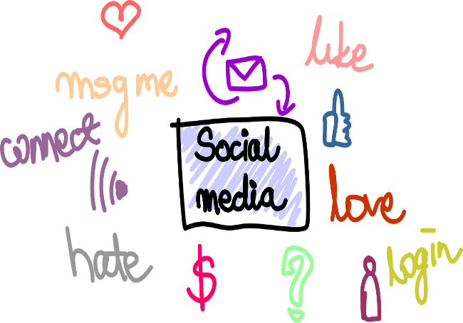 | We also ask you to be active on social media such as Facebook, Instagram, Twitter, LinkedIn, etc.  Social media is continuously growing in importance and developing very fast so that it became essential in project communication. It is, therefore, the responsibility of the communication officers to determine how to use social media on their projects.

If you target to increase your online presence and reach a specific target group, your need to design first your communication strategy on social media, based on who is your target group, which messages you wish to communicate and which are your available resources. The social media platforms can be very useful to providing up-to-date information about relevant project developments. This can be done through:
- The creation, and maintenance of a project social media page at your choice (Facebook, Twitter, Instagram, LinkedIn, etc.).
- Regular posts on project events and developments
- Photos and videos of the project
- Project videos (we recommend using videos of max. 1.5 minute)
When posting on social media, we strongly encourage you to link to the Programme’s social media accounts and use relevant hashtags (eg. #robg, #interreg).
- Twitter: https://twitter.com/ROBGProgramme
- Facebook: https://www.facebook.com/RomaniaBulgariaCbcProgramme?fref=ts
- Instagram: @interregrobg
From our experience, the most used and efficient social media platforms in Romania and Bulgaria are Facebook and Twitter, but of course, you can use any other platform that proves to be successful for your project.
We acknowledge that social media is not without its own set of challenges. If a project can overcome these challenges, social media can ultimately become a success factor.
That said, here are some tips for effective promotion on Facebook and Twitter.

Facebook
What can you post?
Text (no character limit), photos, GIFs, videos, links, etc.
How can you use it?
To showcase your project and results in an informal, highly accessible way.
Instead of using an individual account, Facebook profile, to share project information, we recommend you use a Facebook page.
The most convenient way to promote your project on Facebook, allowing you to post a variety of content including pictures, videos, event invitations or reports, as well as links to presentations or available multimedia material. Facebook pages have fans who like the page, not friends. A page has also the advantage to allow for several nominated users under different types of profiles (admin, editor, reviewer).

Twitter
What can you post?
Text of up to 280 characters. This excludes media attachments (photos, images, videos, etc.) and quoted tweets (displaying someone else's tweet within your own) but includes links (a URL is always altered to 23 characters).
How can you use it?
To share short comments, make announcements that can instantaneously reach a large audience or retweet relevant content.
You can also use Twitter groups to cluster a group of projects on a similar topic.
Tips & Tricks for getting the most out of Facebook and Twitter

- Start by following people and organizations within your network.
The more you follow, the more you are followed.

- Focus on your image

We don’t want to be superficial, but your image matters. Make sure your profile image is visible enough and nice to look at. Upload attractive cover images for your profile.

- Share relevant content

Content is the key to communication. Think what content your fans would expect to see in your page, create it and share it. Relevant content will create engagement. People will like and share your posts and your reach will grow exponentially.
On Twitter, you only have 280 characters per Tweet to create great content. It’s true that this isn’t a lot, so it needs to bring value.
It’s often more difficult to write shorter content than longer content, so tweets need to be on point and easy to read.
Also, statistics show that 80 characters posts or less perform better than longer posts, so this is another reason to cut those long posts down to increase interactivity.
Make them resonate for followers, or drive them to a call to action.

*pro tip: Make use of killer facts to sell a project. E.g.: “A 7% reduction in air pollution in the border region...” and please avoid complex terminology or as we call it “wooden language”. Try to not be too formal in you posts.

- Use images and videos as a regular part of your content strategy

Captivating and relevant images are a great way to increase engagement and reach on your page and posts. Videos now outperform photos in terms of reach. Now is the time to start incorporating images and video into your social content strategy.
Posts with visuals are more attractive and get higher engagement rates. They also compress more information into one post and are more prominently featured in the timelines. Use videos, photos, gifs, vines, emoji’s, etc.

- Ask a Question

Use your Facebook and Twitter pages to pose a question that engages your readers. Use a trending news story to ask your fans’ opinions. Make your questions relevant for what your audience is there for, this will make that post reach more people, fans and potential fans that will then engage in the post and like your page.
Post short, conversational questions that prompt your fans to answer with more than a “yes” or “no.”

- Regularly visit your Facebook Insights and Twitter analytics to find out which content is working with your audience

Visiting your Facebook page’s Insights and Twitter analytics regularly is key. It’s key to learn what your audience likes, and give them more of that. In these sections you will find the posts that have received the most engagement and highest reach so you can share more of what have worked.

- Post when your fans are online

The best time to post depends on several factors that are specific to your audience: What niche are you in? Where is your audience based? When do your followers use Facebook?
The best way to find your best time to post is to look at your own data. In your Facebook Page Insights, under the Post tab, you get data about when your Facebook Page fans are online for each day of the week. Using your data, you can make educated guesses of your best posting time. We would recommend experimenting with times during both the peak and non-peak hours to see which works better for your brand.
Afternoons and late in the week has proven to be more engaging.

- Notice what works

Check which posts performed better and try replicating effective styles in your future posts.
7. Use innovative hashtags.
Use hashtags – but not too many: This will help ensure your content is seen by as many followers as possible. Using hashtags classifies the content so that your posts are grouped with other relevant content. Using hashtags helps other users find your content easily.

Also, when posting on social media, we strongly encourage you to link to the Programme’s social media accounts and use relevant hashtags.
- Twitter: https://twitter.com/ROBGProgramme (#robg, #interreg)
- Facebook: https://www.facebook.com/RomaniaBulgariaCbcProgramme?fref=ts (#robg, #interreg)
- Instagram: @interregrobg

USEFUL ONLINE TOOLS

Presentation tool: Prezi
Publication tools: ISSUU, SlideShare, Calaméo
Pictures publication tool: Flickr
Story tools based on Twitter: Tweetdeck, Moments
Easy infographics making tools: Infogram, Venngage, Visme, Vizualize
Easy graphic design tool: Canva

HOW CAN WE HELP YOU?

We are fully aware that social media advertising is a must if you’re looking to reach a new, targeted audience—fast. Social media’s recent algorithms prioritize engaged content instead of a recency-based feed and social media presence has very much transformed into a “pay to play” model – meaning brands need to “boost” or promote their social media posts and messaging in order to reach anyone at all.
Facebook
There are two ways to advertise on Facebook:
I. Create ads from your business Page
Boost Post -> You can create several types of Facebook ads from your business Page. One way and the easiest is to boost a post.
To create a boosted post:
1. Go to your Facebook Page
2. Find the post you want to boost.
3. Select Boost Post. You can find it in the bottom right-hand corner of your post.
4. Fill in the details for your ad. Facebook will automatically use images and text from your post, but you can choose the following details:
- Audience: Choose a recommended audience or create a new audience based on specific traits.
- Total budget – to be set by you
- Duration – Select one of the suggested timeframes or provide a specific end date.
- Payment method: - review your payment method
5. When you've finished, select Boost Post Now.
- Create ad campaigns using Ads Manager
Facebook Ads Manager is a tool designed to give you full control of the types of ads you run, their format and the audiences they reach. Additionally, it allows for more granular settings for scheduling and budgeting.
- Head to https://www.facebook.com/ads/manager. You will be brought directly into the Facebook Ads Manager of your personal ad account.
- Select Create
- Choose an objective from the list best aligned with your goals.
- Enter a descriptive name in the Campaign name text box.
- When creating ads from scratch, you can choose from two workflows to create and manage your ads:
Guided creation: This option guides you through the steps to create a campaign to completion.
→ Choose this workflow if you are new to Facebook ads and want step-by-step instructions.
Quick creation: This option allows you to set up the campaign and then create ad sets and ads later.
→ Choose this workflow if you're an advertiser with more advanced skills and are already familiar with the creation workflow.
- Define your audience
  - Choose or create a Custom Audience (optional).
  - Hover over Locations, Age, Gender and Detailed targeting and select to edit.
  - Select Show more options to customize Language or Connections.
  - Select to Save this audience for future use.
- Select your ad placements. This is where you'd like your ads to appear across Facebook, Instagram or Audience Network.
- Select Automatic placements, which lets us to show your ads where they're likely to perform best.
- Or, select Edit placements to choose your ad placements manually.
- Set your budget - set a lifetime budget.
- Set a start and end date
Create an ad
Once you've created your campaign, you can move on to creating your ad. This is where you'll select your ad's creative and add text.
- Select your Page. All ads are required to have an associated Facebook Page.
- Select an ad format. Choose from several ad formats, including: Carousel, single image or video, or collection. You can create a slideshow if you select the single image or video format.
- Choose the creative, or media, that you want to use for your ad.
  - To upload or choose from previously uploaded images or video, select Add media.
  - To create slideshows or use video templates, select Create media.
- Add the text that you'd like your ad to display.
  - Depending on your previous selections, you may have the option to add a call-to-action button, choose a pixel and more.
- Preview your ad and select Confirm.
  - To see how your ad will appear across placements, select the placement icons alongside your ad preview.
  - The first time you publish an ad, you'll be asked to enter your payment information.
Your campaign is now live (pending review from Facebook). There is no need to review and publish. Facebook will publish your ad upon approval.

Twitter ads
Twitter offers two ways for brands to create Twitter ads:
- Twitter Promote automatically promotes Tweets for you.
- Twitter Ads campaigns allow you to set up campaigns yourself based on your marketing objective.
Twitter Promote
How to Promote a Tweet
1. Select "Promote Mode" from the campaign menu and click "Get started”. When you're done, click "Next" on the top-right-hand corner of the page.
2. Select your promoted tweet's country and time zone. When you're done, click "Next" on the top-right-hand corner of the page.
3. Choose either "Interests" or "Location" as your targeting method.
Twitter can promote tweets to an audience based on their interests or location. Choose one of these methods and follow Step 4 or Step 5, below, depending on your choice.
4. Choose up to five interests associated with your target audience.
If you choose to target an audience based on their interests, select this option and hit "Next”. Here, you can select a maximum of five interests related to your ideal audience.
Keep in mind the more interests you select, the more types of people your promoted tweet will appear in front of.
5. Choose up to five locations associated with your target audience.
If you choose to target an audience based on their location, select this option and hit "Next”. Here, you can search a specific city, state, and country where you want your ad to appear.
6. Review your ad criteria and select "Proceed."
Once you've customized your audience's interests or location, hit "Next" and Twitter will show you an overview of your ad criteria, including your bill.
Sound good to you? Review your ad criteria and check that you agree to the Twitter Promote Mode's Terms of Service at the bottom of this page. Then, click "Proceed" on the top-righthand corner of your screen.
7. Add your billing information and launch your promoted tweet.
If you haven't yet added billing information, Twitter will ask you to enter it in the following screen. Select "Save" and follow the prompts to officially promote your tweet.
Twitter ad campaigns
With Twitter ad campaigns, you first choose a business objective that aligns with your business goals.
You can select existing organic Tweets to promote, or create Tweets specifically as ads.
You can find the detailed steps below:
1. Select your Twitter Ad's objective.
You have eight objectives to choose from, and you can see an elaboration of each objective once you select one.
- App installs
- Followers
- Tweet engagements
- Promoted video views
- Website clicks or conversions
- App re-engagements
- In-stream video views (pre-roll)
- Awareness
2. Fill in the details your ad campaign.
Once you choose an objective, you'll be taken to a page where you can name your campaign, a start and end date for your campaign, and your campaign's total budget.. You'll set a daily budget and an optional total budget. Throughout the day, your daily budget will pay Twitter your set amount at the specific cadence you can set yourself.
The cadence of your promoted content can be set to "Standard” (recommended), which shows ads to your target audience at intervals Twitter deems most efficient; or "Accelerated," which shows your ads as much as possible throughout the day. Accelerated ads cater to ad campaigns you want to perform well in a short amount of time.
3. Create an ad group within your campaign.
Next, you'll create an ad group for your campaign. Enter an ad group name, a start and end time, a budget for the ad group, and a bid type. Bid types allow you to "bid" on a promoted ad placement. Ad placements will cost different amounts depending on your audience and where the ad appears on Twitter, and you can set your ad group to bid for placement in one of three ways:
- Automatic bid: This type of bid permits Twitter to bill you the most cost-effective amount every time your audience engages with your ad content. The cost Twitter bills you is based on your ad group's budget and audience parameters.
- Maximum bid: This type of bid gives you full control over how much money you're willing to pay every time your audience engages with your ad content.
- Target bid: This type of bid allows you to specify how much money from your ad group's budget you'd like Twitter to bill you every time your audience engages with your ad content. The price you're billed will reflect the daily average cost of each ad placement within your audience.
4. Select your target audience.
This is where you'll set the parameters of your target audience.
It's important to customize your audience to be a good fit for you and your message. That way, you're only paying for engagement from folks who might have some interest in learning more about your project. A more targeted audience is more likely to help you generate qualified leads.
What are my options?
You can customize the following criteria:
- Gender
- Age
- Location
- Language
- Device
Audience features: These include keywords, movies & shows, conversation topics, events, and related interests.
You can also select which devices you'd like your promoted tweets to be displayed on -- any combination of desktop and the various mobile devices.
Targeting by Keywords - an option included in the "Audience features" field, allows you to reach people that search, tweet about, or engage with specific keywords, so you might filter your audience by keywords you consider relevant to a specific advertisement.
Targeting by Interests and Followers - allows you to create a list of Twitter usernames and then target users whose interests are similar to the interests of those users' followers.
5. Select the creatives you'd like to run with each ad group.
Your last task in creating a Twitter Ads campaign is to choose the creatives you want to run with each ad group belonging to your campaign. "Creatives" are simply the tweets you want to promote, and you can select them from the list of tweets that appear under the Creatives tab.
You can either select from existing tweets in your account or create new ones.
6. Review and launch your campaign.
Finally, select the "Review your campaign" button, to look over your campaign details. If everything looks correct, hit "Launch campaign" at the top-right-hand corner of your screen to run the campaign.
VIDEOS

Videos are a great way to promote your achievements. Social media users are looking for entertaining posts. They are spending time on social platforms to kill time, see interesting news, communicate with their friends, so you need to get their attention with entertaining content. And what better way is there than through video?
Keep your videos short and on point. You could create videos that shows people and situations in a realistic, spontaneous and natural-looking staging, feature interviews with people directly benefiting from your project, use storytelling to show how a bad situation in the region was improved by your project.
Tips for creating an attractive, professional type video:
- Keep it short, maximum 2-3 minutes. If your topic is complex and needs a lot of explanation, you can break it down into smaller pieces.
- Know the goal you want to achieve with the video. Plan it well, by creating a story board.
- Keep language simple and make your content as clear and easy to navigate as possible. The more difficult the content is to understand, the easier the video should be.
- Choose facts and figures that are understandable. Get people's attention with statistics they can refer to.
- Capture attention early. Create and disseminate videos auto-play on most social media platforms. By capturing attention with the first few seconds you have higher chances of stopping viewers.
- Design for audio off. People watch videos from mobile everywhere so it might be useful to add subtitles to the video.
- Use videos to increase the visibility of projects and their results by recording dissemination activities, such as events and conferences. You can show their preparation, discussions, follow-ups, and even backstage.
- Interact with your audience as much as possible. Respond to comments and answer to questions.
- Upload your videos to the channels used by your target audience, making sure to use appropriate formats for each social media
PROJECT POSTERS

According to the EU-Regulation 1059/2021, for Interreg operations for which the total cost of the investments or equipments is bellow EUR 100 000, every project partner will have to display at least one poster of a minimum size A3 or equivalent electronic display with information about the Interreg operation highlighting the support from an Interreg fund, in a prominent position in their organization.
You are free to design the poster according to your own wishes as long as it complies with the minimum communication standards of the Programme. You can find all about it in the Visual Identity Manual.
PROJECT BILLBOARDS/PLAQUES

Are you planning to construct/build something during your project? In that case you will have to install a large temporary sign (plaque or billboard) for each project on a prominent place, as soon as the physical implementation of an Interreg operation involving physical investment or the purchase of equipment starts and the total cost of which exceeds EUR 100 000. You can find all the information about how the billboards/plaques should look like and which are the mandatory requirements to be included in the Visual Identity Manual.
- Important: For operations of strategic importance and operations whose total cost exceed EUR 5 000 000, it is compulsory to organize a communication activity and involve the Commission and the Managing Authority in a timely manner.
PUBLICATIONS

Furthermore, we would like to ask you to incorporate Interreg VI-A Romania-Bulgaria Programme in your publications in the media and in all communication materials there are multiple ways of referring to our Programme. According to EU-Regulation 1059/2021, on all documents and communication materials relating to the implementation of an Interreg project, a statement highlighting the support from the Interreg fund should be placed in a visible manner. You can, for instance, include a paragraph describing the Programme (check out the “About the Programme” section on our website). You can use it as an introduction, communicating the broader framework and illustrating the impact of the Programme. This way you can add some extra weight to your own project. You can of course use a quote of your own, but please take into account that it should show the level of support provided by ERDF, including its aim and results, and highlighting the financial support.
It goes without saying that we will share your publications via our communication channels too through social media, but also through news articles on our website. Additionally, we are willing to help you in your events or press contacts.
Publications can be disseminated electronically. Printing of publications should be foreseen only if strictly necessary and only if following a sound dissemination plan.
- Short, clear and “to-the-point” publications should be preferred to long ones and images should be reduced to save printing space.
- Publications should be printed for external communication purposes (if needed only) on both sides and on recycled paper. For electronic publications, a “printer-friendly” version (less colors, more compact text, less pages) should be made available.

NEWSLETTERS

As paper newsletters are costly and less-effective, we prefer electronic newsletters, which are in line with our environmental-friendly policy.
A newsletter in electronic format can be an effective communication tool. It can also be a good way to draw attention to the news published on your website or social media pages.
As for any communication tool it is important to remember who your readers are. The content, frequency and format need to match your target group.
PROMOTIONAL MATERIALS

Promotional materials are usually small and inexpensive. They should be informative, clear and attractive to the addressed target groups, but the real power of promotional items comes from their lasting power, which is the result of a product’s utility as well as its sustainability. And we’re all about sustainability and going green.
Promotional items are by definition produced in larger quantities and come custom-printed with the Programme logo. Their production has to respect horizontal principles of equal opportunities, non-discrimination, sustainable development and environment protection.
So, before purchasing promotional materials, please ask yourselves: in today’s digital era, are promotional products still useful? After all, tweets and Facebook posts cost far less than physical bulk items do.
However, limited promotional materials are allowed under the Programme, such as:
- Pen and pencils
- Paper notebooks
- Bags (made of sustainable materials like cotton, paper or linen)
- Cardboard conference folders
- USB sticks
If you decide that you still need them, please make sure that they:
- Are manufactured in a sustainable fashion
- Do not contain toxic materials or ozone-depleting substances
- Can be recycled and/or are produced from recycled materials
- Are made from renewable materials
- Do not make use of excessive packaging
- Are designed to be repairable and not throwaway
All promotional items must respect the green principle and the quantity produced should be reasonable and justified. The cost of a single item should not exceed EUR 50.
For each non-investment project, we encourage you to plant at least 2 trees, and for each investments project, at least 5, during the project implementation. So, you will need to prove you have planted at least 2 trees, and for each investments project, at least 5, during the project implementation, if you decided so.
You can plant your trees on public spaces or near to your headquarters. When selecting the trees, please make sure you have chosen local species (please do not use alien and invasive species) and that you can take care of them in the future.
EVENTS

It is compulsory to organize a kick-off event within two months after the beginning of the project implementation. Project partners, relevant stakeholders/final beneficiaries/decision-makers should attend these events. The representatives of MA, NA and JS (project officers) could also be invited. We recommend the audience to be as wide as possible and don’t forget to ensure visibility of the EU flag and the Programme logo.
Other events can be organized as well. Events should be organized in such a way as to attract target audiences and media interest. Typical project events include conferences, seminars, exhibitions, field trips, kick-off and closing events, open doors events, but we would really like you to step out of the box and be as creative as possible when designing your events. You can also join forces with other thematically relevant projects to organize joint events. This can save human and financial resources and get more people to see the benefits brought by your project.
Additionally, participation in external events is a good way to promote the project as well as of the institution or region involved.
Two of the major promotional events organized in the European arena where programmes and projects can take part in are:
European Cooperation Day – a Europe-wide campaign called European Cooperation Day (EC Day) with the aim of high-lighting results of European cooperation across borders to the general public. We celebrate “EC Day” on 21 September every year. Everybody can join the celebration and many events are organized in different regions of Europe in order to show the benefits of cooperation. Film festivals, concerts, running races, local markets, exhibitions, sport events, gastronomic fairs are only a few examples of the awesome events that have taken place. You can find more info on www.ecday.eu.
European Week of Regions and Cities - the biggest annual Brussels-based event dedicated to regional policy. You can find more info here: https://europa.eu/regions-and-cities/home_en

Tips for organizing a successful event

- Define the purpose and format
Formulate your goal as specifically as possible. Ask yourself: What do we want to achieve with the event? The format of the event will depend on the answer: its concept, timing and duration, role distribution within the team, the layout of the hall, catering etc.
Try not to get stuck in traditional formats and move away from very formal conferences, when possible, of course. Online or open-air events are much appreciated. What counts is that your format helps to achieve the goal of the event.

- Pay attention to planning
The plan should include logistics, content and the promotion of the event. The entire project team should cooperate. Create a list of the main tasks and then describe them in as much detail as possible in the form of specific steps that each member of the team should complete. It is important to designate the time required for completing each task. It is often underestimated and preparation goes slower than you expected, so you have to plan your events carefully in your Application. The procurement processes are often time consuming, but can luckily be done well in advance.
- Draft your budget
Look at the list of tasks and reflect them in your budget. It is also worth thinking about a reserve in case of unforeseeable situations. Take into account the public procurement procedures and the time needed to contract services.
4. It’s all in the details
If you want to pleasantly surprise your guests, think about everything down to the smallest detail: how the participants register, who will greet them and how, do you have an interesting photo corner, how do your presentations look, what to do during breaks, consider hiring a professional photographer for bigger events.
For example, during registration, participants could be offered the chance to attend a brief master class, play games or watch an information video.
Try to surprise people and create the wow effect, exceed their expectations in the most ordinary things. This is exactly what creates the feel of a successful event.
- Check the location and have a plan B
A good venue should have good accessibility for the participants, a right sized room, a suitable place for potential catering services and should also be appropriate for the technical equipment you will need for holding the event. Always check the location in person as early as the selection stage, in order to avoid unpleasant surprises.
It’s always best to have a plan B. Imagine if you have an open-air event and it rains all day. So, always think such things in advance and be well prepared.
- Allocate responsibilities
It is very important to distribute tasks among the team members not only at the preparation stage but also during the event. Allocate responsibilities by zone. For example, someone is responsible for the registration zone, someone else for greeting the speakers, a different person for the equipment, for catering, communication with the press, etc. Every person needs to have his or her zone, which he or she should be responsible for throughout the entire event.

- Tell your audience about the event
Do not underestimate the power of promoting an event. You should notify target audiences well before the event. It’s important to create one key message that will be broadcasted on all channels. Make sure it is brief and that it accurately conveys the idea of the event to your audience. You could send a “save the date” message first and give more details of the event later on. Newsletters are also great for the marketing of the event.
Also, we can help you by promoting your event on the Programme website/ Facebook page
- Pay attention to service
Be friendly to participants, speakers and partners. Try to address their problems or questions and meet their expectations. At the end of the day, what people remember most is how they were treated and the atmosphere.
- Carry out a final check 24 hours before the event
Make sure that you’ve informed the participants of how to get to the location, invited all the important guests, prepared all the necessary materials and all technical equipment is functioning properly. Check whether everyone understands his or her tasks and responsibilities and whether the space is ready. Checklists are always a great tool.
- Ask for feedback
You’re probably going to be pretty tired after the event, but it will be difficult for you to give an objective assessment of how it all went. That is why you should ask participants to complete an evaluation form at the end of the event. You already know we don’t like paper, so consider using an online form. Ask them to assess various aspects of the event: logistics, speakers, locations, and the work of the organizers. This information will help you to avoid mistakes in the future and improve the quality of your events. If possible, get feedback through social networks or record video reviews at the end of an event. This will come in handy if your event is held again.
In planning and organizing your event, you may use the following templates, attached to this guidelines, that you consider useful: Concept of the event, Checklist for organizing the event, Feedback form.
Ecotips
Go paperless or if you really have to use paper, make it recycled one
We aim for all events to become paperless and plastic-free and to minimize environmental impact. We encourage you to use environment-friendly materials before and during the event. There is no real need to print anything for a project implemented in our Programme.
Brochures, flyers and other printed promotional materials were proven to be inefficient and thus we are reluctant to finance such expenditures.
However, we are not know-it-alls. In case you do have to use paper to print something, use recycled paper. It’s a well-known way to conserve resources. Most providers offer an option to supply you with recycled paper.

VISUAL IDENTITY MANUAL

In the Visual Identity Manual (VIM), you can find all the rules to be followed on corporate identity, explained in detail. The VIM is drawn up to support the management structures of the Programme and the beneficiaries of the projects financed under the Programme in fulfilling the requirements regarding the information and publicity measures set up by the EU Regulations. The JS also helps the projects in fulfilling these rules and supports them constantly in all their communication activities.
Important notice: Non-compliance with the rules on branding could lead to negative effects including cancelling up to 2% of the support from the Funds to the beneficiary concerned.

